Exercise 1: Configuring a Basic Spring Application

Software Requirements
- Eclipse IDE
- JDK 8 or above
- Maven
- Spring Framework

Project Name
LibraryManagement

Project Structure
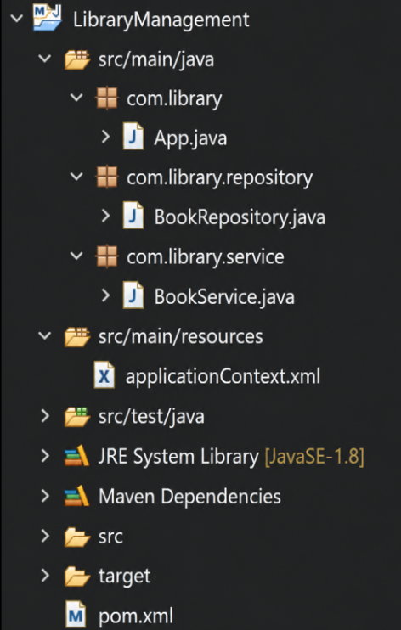

pom.xml
<?xml version="1.0" encoding="UTF-8"?>
<project xmlns="http://maven.apache.org/POM/4.0.0"
xmlns:xsi="http://www.w3.org/2001/XMLSchema-instance"
xsi:schemaLocation="http://maven.apache.org/POM/4.0.0 https://maven.apache.org/xsd/maven-4.0.0.xsd">
<modelVersion>4.0.0</modelVersion>
<groupId>com.library</groupId>
<artifactId>LibraryManagement</artifactId>
<version>1.0</version>
<packaging>jar</packaging>
<dependencies>
<dependency>
<groupId>org.springframework</groupId>
<artifactId>spring-context</artifactId>
<version>5.3.30</version>
</dependency>
</dependencies>
</project>

BookRepository.java
package com.library.repository;
public class BookRepository {
public void displayRepository() {
System.out.println("Book Repository Bean Created");
}
}

BookService.java
package com.library.service;
import com.library.repository.BookRepository;
public class BookService {
private BookRepository repository;
public void setRepository(BookRepository repository) {
this.repository = repository;
}
public void displayService() {
System.out.println("Book Service Bean Created");
repository.displayRepository();
}
}

App.java
package com.library;
import org.springframework.context.ApplicationContext;
import org.springframework.context.support.ClassPathXmlApplicationContext;
import com.library.service.BookService;
public class App {
public static void main(String[] args) {
ApplicationContext context =
new ClassPathXmlApplicationContext("applicationContext.xml");
BookService service =
context.getBean("bookService", BookService.class);
service.displayService();
}
}

applicationContext.xml
<?xml version="1.0" encoding="UTF-8"?>
<beans xmlns="http://www.springframework.org/schema/beans"
xmlns:xsi="http://www.w3.org/2001/XMLSchema-instance"
xsi:schemaLocation="http://www.springframework.org/schema/beans
https://www.springframework.org/schema/beans/spring-beans.xsd">
<bean id="bookRepository"
class="com.library.repository.BookRepository"/>
<bean id="bookService"
class="com.library.service.BookService">
<property name="repository" ref="bookRepository"/>
</bean>
</beans>

Output
Book Service Bean Created
Book Repository Bean Created
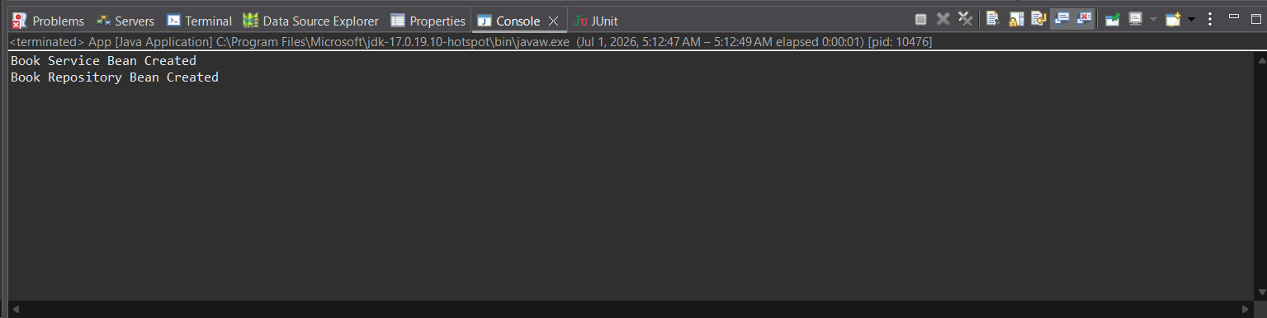

Result
Successfully configured a basic Spring application using XML configuration. The Spring IoC container created and injected the beans successfully.

